- Load the Customer Segmentation Tutorial Dataset from Kaggle into a Jupyter Notebook and display the first 10 rows using pandas.
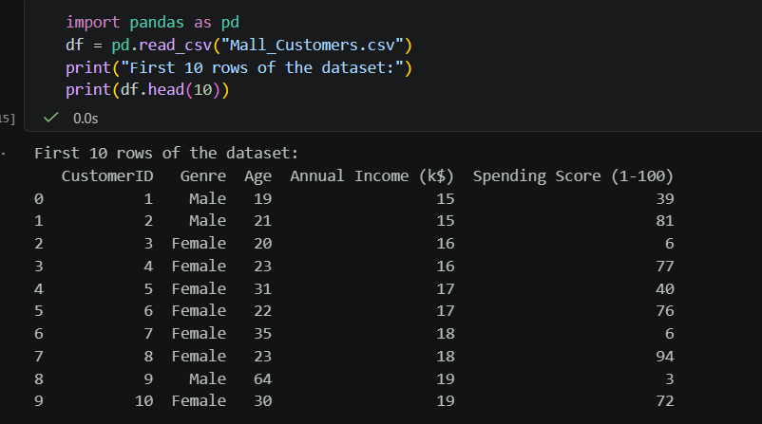

===========================================================================

- Use pandas to check for missing values in the Age, Annual Income, and Spending Score columns, and print the total number of missing values for each.
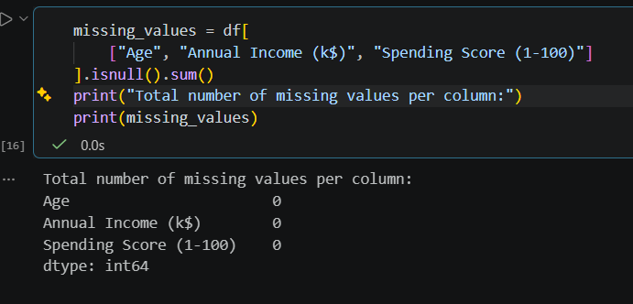

- Create a scatterplot of Annual Income vs Spending Score using matplotlib or seaborn to visualize how customers are distributed. Use seaborn.scatterplot() or plt.scatter().
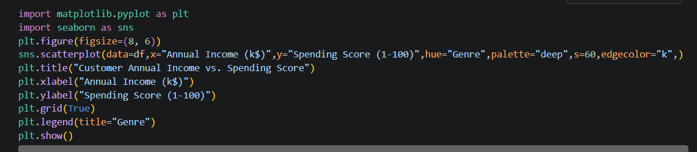

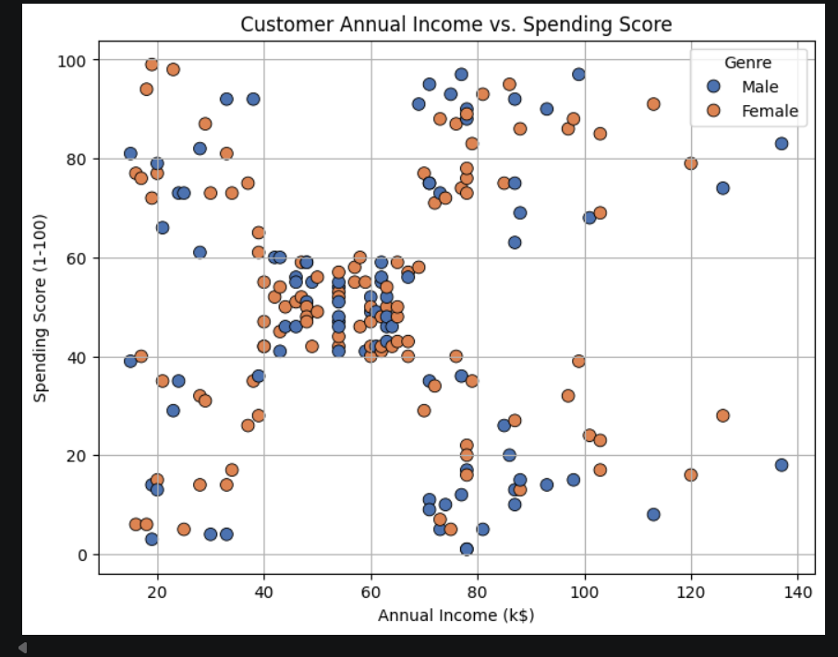

- Generate a heatmap of the correlation matrix for the numerical features in the dataset using seaborn, and interpret which two features are most strongly correlated.
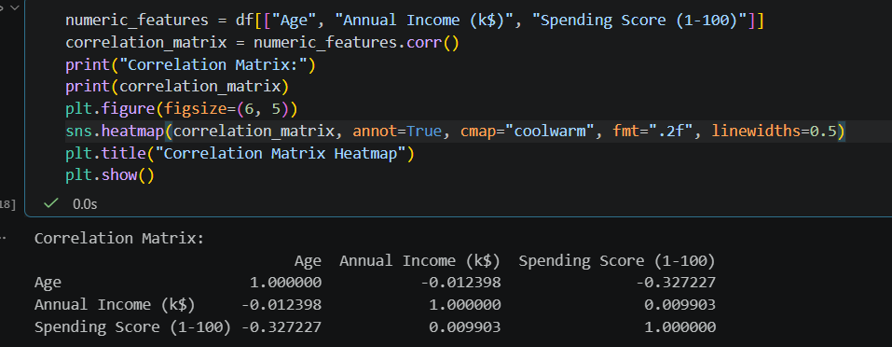

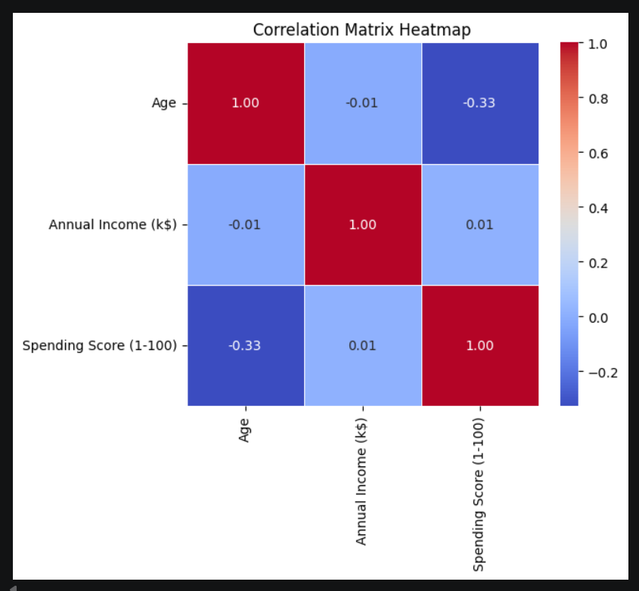

The two features most strongly correlated in this standard subset are Age and Spending Score (with a correlation coefficient of approx. -0.33), showing a weak-to-moderate negative relationship where younger customers tend to have higher spending scores. Annual Income shows nearly zero linear correlation with Age and Spending Score in isolation.

===========================================================================

- Apply K-Means clustering (from sklearn.cluster) to segment customers into 3 groups based on Annual Income and Spending Score, then add a new column 'Cluster' to your DataFrame with the assigned cluster for each customer. Use only the two features for clustering, and set random_state=42 for reproducibility.

